**PHASE 4: DEPLOYING THE MACHINE LEARNING MODEL AND**

**TESTING IT IN IBM CLOUD**

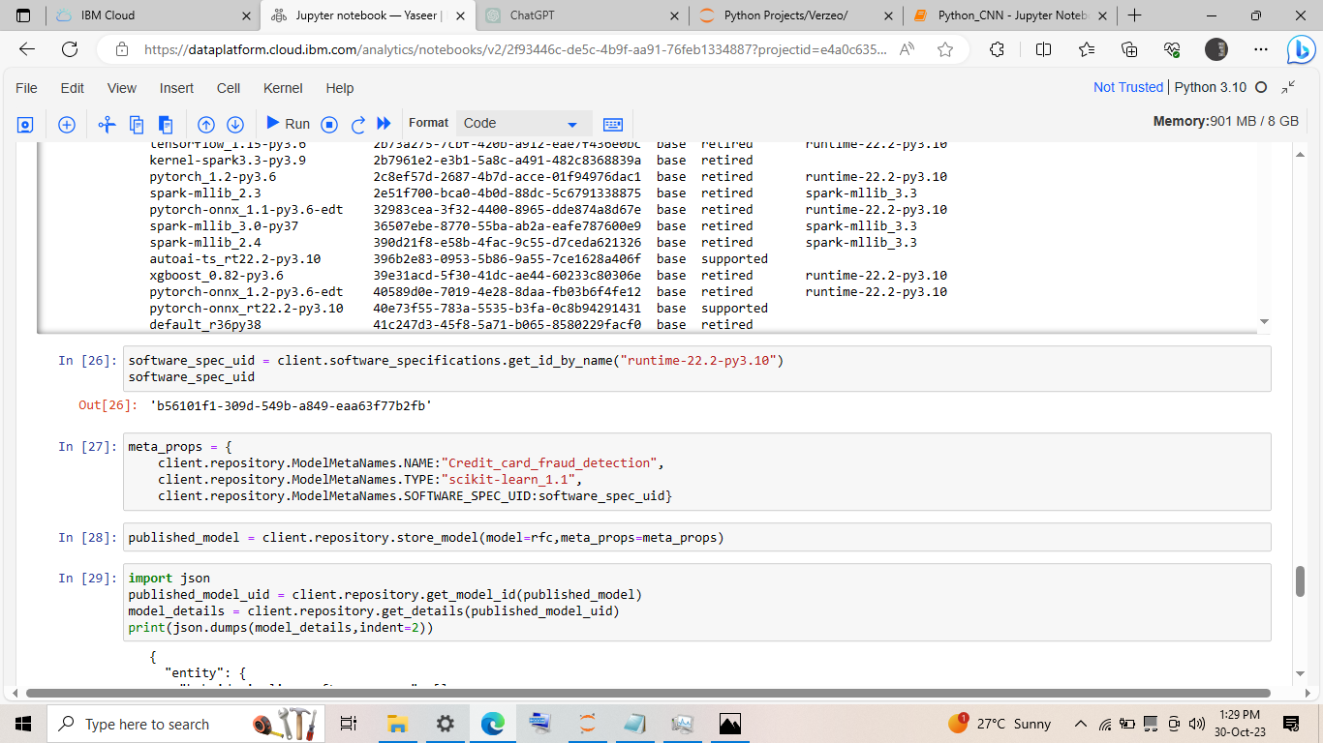CODE TO STORE MODEL IN IBM CLOUD:

* After this the model is stored as an asset in the deployment space created in the IBM cloud.
* Then Deployment space🡪Assets🡪Select model🡪Deploy to deploy the ml model in IBM cloud.

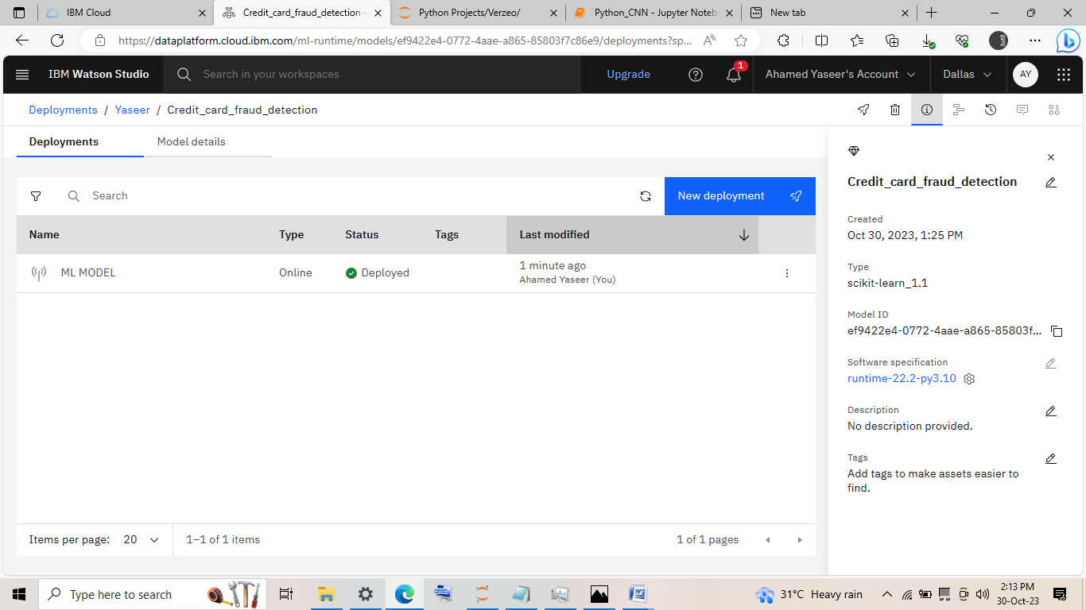Deployed model:

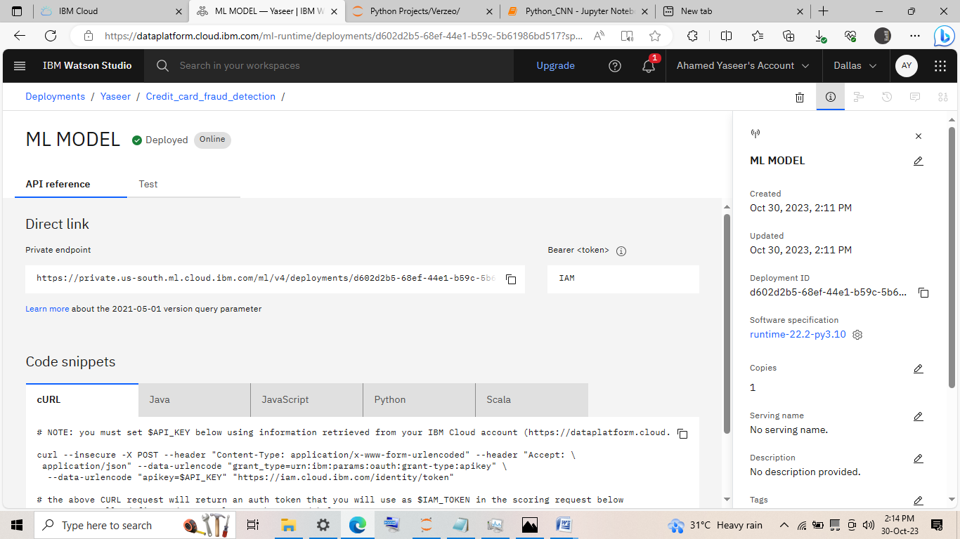

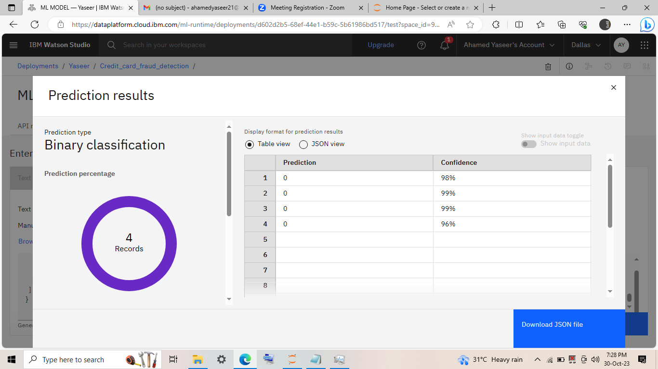Testing the model:

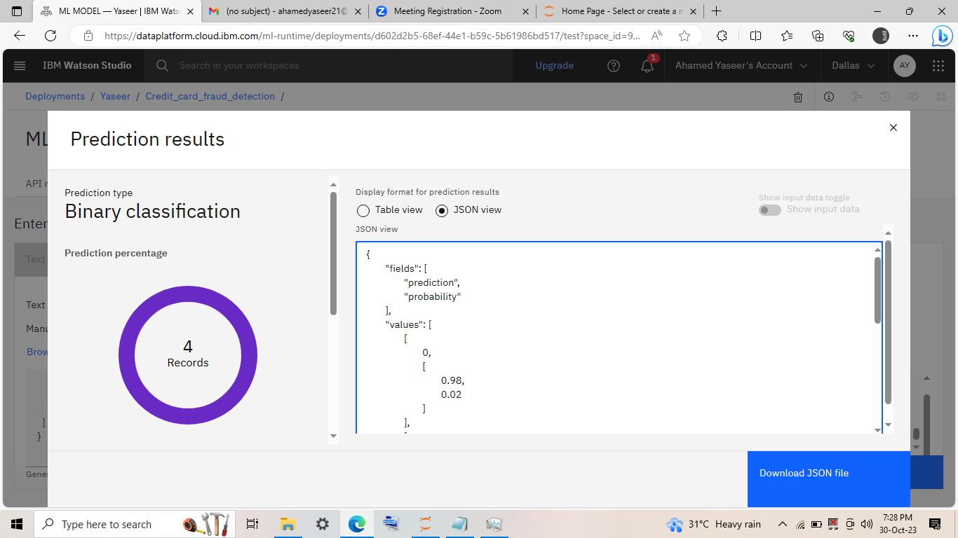

Accessing the ml model using the API end point created:

